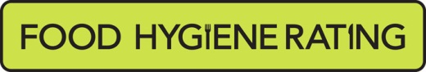
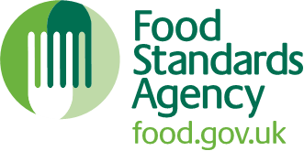

Food Hygiene Rating Scheme: Appeal form

Notes for businesses:
- As the food business operator of the establishment you have a right to appeal the food hygiene rating given following your inspection if you do not agree that the rating reflects the hygiene standards and management controls found at the time of the inspection.
- You have 21 days (including weekends and bank holidays) from the date of receipt of the notification letter to lodge an appeal.
- Please use the form below and return it to the Lead Officer for Food from your local authority – contact details are provided with the written notification of your food hygiene rating.
- Your rating will be reviewed and the outcome of your appeal communicated to you within 21 day

Business details
Food business operator/proprietor | Click or tap here to enter text.
Business name | Click or tap here to enter text.
Business addresses | Click or tap here to enter text.
Business tel. number | Click or tap here to enter text.
Business email | Click or tap here to enter text.

Inspection details
Date of inspection | Click or tap here to enter text.
Food hygiene rating given | Click or tap here to enter text.
Date notified of rating | Click or tap here to enter text.

Action taken
I do not agree with the food hygiene rating given by the food safety officer because (please explain below under each of the three headings).

Compliance with food hygiene and safety procedures | Click or tap here to enter text.
Compliance with structural requirements | Click or tap here to enter text.
Confidence in management/control procedures | Click or tap here to enter text.

Signature

Name - in capitals | Click or tap here to enter text.
Position | Click or tap here to enter text.
Date | Click or tap here to enter text.
Please now return this form to:
Hertsmere Borough Council
Environmental Health
Civic Offices
Elstree Way
Borehamwood
Herts WD6 1WA

T: 020 8207 7435

E: Environmental.health@hertsmere.gov.uk

