Bushey Heath High Road

Conservation Area Appraisal

Public consultation – 17 June to 29 July 2013

We have undertaken a review of the Bushey Heath High Road Conservation Area, which includes Windmill Lane, High Road and Hartsbourne Park
We are proposing removing its status as a conservation area, which is known as de-designation, and using alternative ways of protecting the character of the area.

Before any changes are considered we would like to hear from local residents, businesses and anyone else who has an interest in the conservation area and its future development.

A public consultation will run from Monday 17 June until Monday 29 July 2013 at 5pm. We will also be at St Andrew’s Methodist Church in Bushey Heath to answer questions and discuss plans on Tuesday 2 July 2013 between 2pm and 7pm.

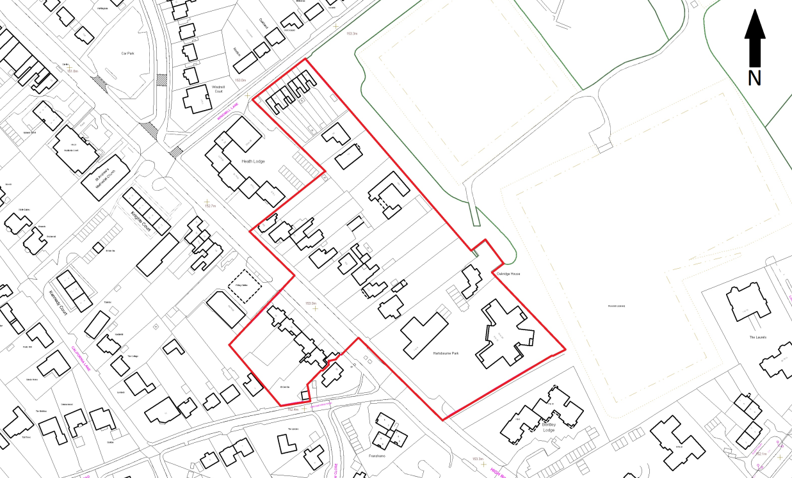

What did the review look at?
A conservation area is used to protect and enhance the historic character of the area The Draft Bushey Heath High Road Conservation Area Appraisal looked at the ways in which the character of the Bushey Heath High Road Conservation Area could be preserved and enhanced for future generations. Different areas or ‘character zones’ within the area were analysed in detail, taking in what were considered to be good, neutral and bad features. The ‘character areas’ are shown in the map:

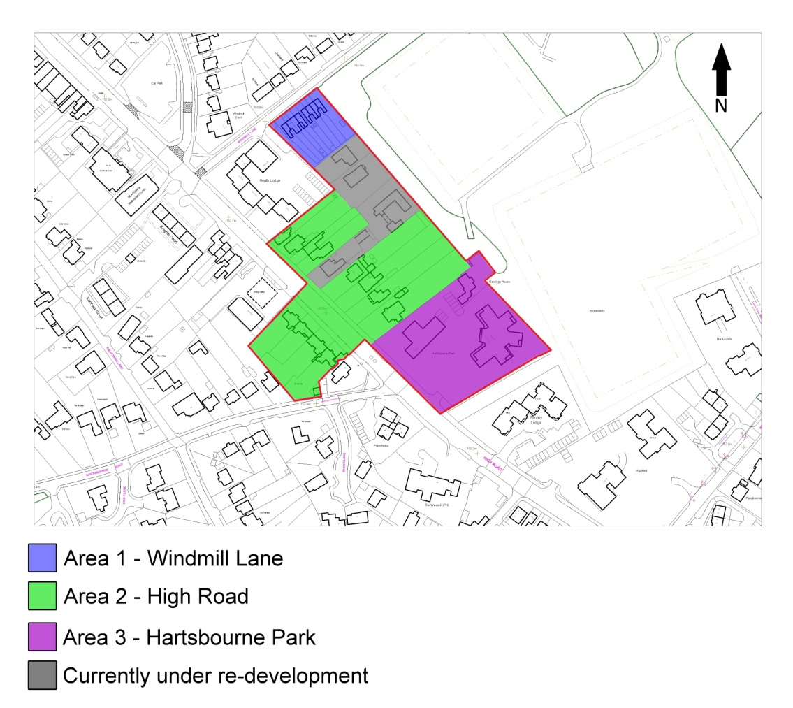

Area 1 contains two blocks of four terraced Victorian houses, which have had a good number of changes that do not contribute positively to the historic character of the area, including inconsistent or inappropriate extensions, and changes to window openings.

Area 2 is the core of the conservation area with the most historic assets. It contains a Tree Preservation Order (TPO), seven listed buildings in the area and four buildings proposed for the list of locally important buildings. The character of the High Road has also been significantly enhanced by more vegetation and brick walls.

Area 3 is the Hartsbourne Park site, which is not historic, but does benefit from the protection of a TPO on all the trees in the area and attractive front boundary walls and hedging. The grey area is the recently built site and not considered to add to the historic character.

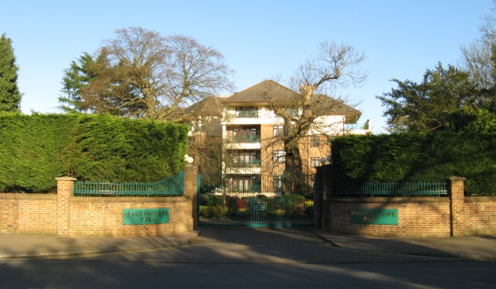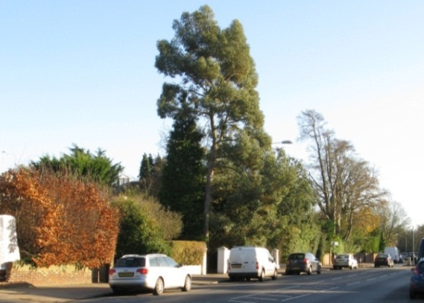

What are the proposed changes?
We feel that the Bushey Heath High Road Conservation Area has the potential to remain an attractive area, but a conservation area is not an appropriate way to manage the area and other forms of protection for specific features would be more effective.
When the area was designated a conservation area in 1990, Hartsbourne Park, which had just been granted planning permission was included in the designation. It’s thought that the original designation of the conservation was just acceptable at the time, and it is now infrequent to de-designate an area.
Unfortunately, changes have been made, through permitted development rights, the granting of planning permission and other street scene changes, that have had a cumulative and negative effect on the historic character of the area

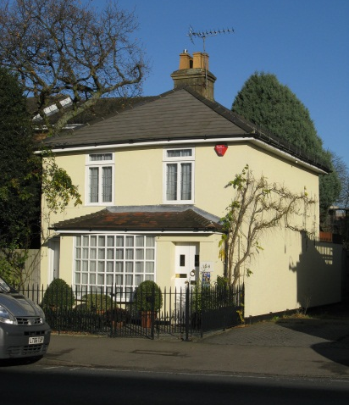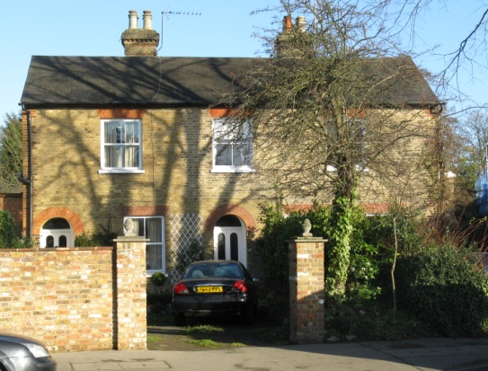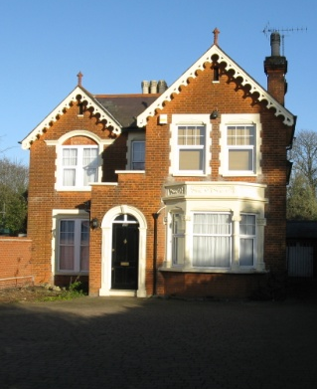

It is also recommended that:
- Homes on the High Road including numbers 158, 160, 162 and 168 are considered as Locally Important Buildings;
- The area is reviewed for significant trees for potential protection orders; and
- An Article 4 Direction is considered for the replacement of front boundary treatment along High Road.

Will the area be affected if the conservation area is de-designated?
It is felt that the conservation area has not satisfactorily protected the character of the area over the last 23 years. If the conservation area were removed or de-designated other measures could be used to protect valuable features in the area. These measures would be in place before any de-designation takes place.
How can I give my views?
Before we make any changes we would like your input. Are you aware of any other important areas for improvement? Do you have any innovative ideas for managing the character of the area?

You can use the response form provided or write to us to give us your views. Address it to:
Policy and Transport Team
Planning and Building Control Unit
Hertsmere Borough Council
Civic Offices, Elstree Way
Borehamwood, WD6 1WA
Or email us at: local.plan@hertsmere.gov.uk

Please note that the closing date for responses is 29 July 2013 at 5pm.

The full version of the Draft Bushey Heath High Road Conservation Area Appraisal is available to view at Civic Offices in Elstree Way, Borehamwood, the Bushey Area Office in High Street, the Bushey Library, and the Bushey Museum and Art Gallery.

A PDF version of the full document is also available to download online from:
www.hertsmere.gov.uk/busheyheathhighroad

What will happen after consultation?
Once we have received all your comments we will consider these and make any adjustments considered necessary. Also, we will notify you of any boundary changes that affect your property. The final decision on the document and any changes will be considered by our executive committee.

