**Hertsmere Borough Council**

**2024/25 DRAFT BUDGET SUMMARY**



**Background**

At its meeting on 10 January 2024 our Cabinet considered the draft revenue budget for the next financial year (2024/25) and recommended this budget for consultation before we present the final budget to a meeting of the Full Council for approval on 28 February 2024. As a key stakeholder we would like to seek your views on our budget proposals.

This document provides a summary of some of the key elements of our draft revenue budget for 2024/25. The detailed draft revenue budget report can be found on the 10 January 2024 Cabinet agenda pages of our website via the following link:

[www.hertsmere.gov.uk/councilagendas](http://www.hertsmere.gov.uk/councilagendas)

**Setting the 2024/25 revenue budget**

The 2024/25 revenue budget has been set under challenging economic conditions. Whilst the economy is slowly recovering, from the turmoil caused by various factors including Brexit, the Covid-19 pandemic and the war in Ukraine, lifestyle changes as a result have impacted on demand for our services and more widely is impacting on labour markets. Inflation has significantly reduced over the past 12 months and is now just 3.8% compared to 10.1% at the same time a year ago. Interest rates are believed to have peaked at 5.25% and are expected to reduce falling to 4.0% by the end of 2024/25. The increased cost of living however continues to have a significant impact on household budgets affecting our residents and staff.

When setting the 2024/25 budget we have considered many factors. Some of the main considerations are:

* **Economy and Cost of Living** – the overall economic climate and the rising cost of living has a potential impact on service costs and the ability to generate income through fees and charges.
* **Recruitment and Retention – the current labour market has become extremely challenging and continues to have a detrimental impact on services such as waste management and civil enforcement but has also impacted other service areas such as planning.**
* **Pay** – in light of the above, coupled with the rising cost of living, staff expectations for a significant pay increase are high. A 4% pay award has been built into the 2024/25 budget.
* **Income** – whilst budgeted income from rent, sales, fees and charges is set to rise from £17.4m in 2023/24 to £18.5m in 2024/25, the majority of income budgets are subject to external factors, such as supply and demand, market forces and the general state of the economy and competitiveness of the market.
* **Government funding and policy** – the provisional finance settlement announced in December 2023 provided details on 2024/25 government funding, policy and referendum limits set for Council Tax increases.
* **Council Tax** – in line with Government funding policy this draft budget proposes a Council Tax increase of 2.99% equivalent to £5.95 for an average band D property.
* **Other legislation changes** are also considered such as the proposed national changes to waste management and local planning.

**Balancing the budget**

Setting a **“Balanced Budget”** for the year ahead is a **Statutory Requirement** for us. A balanced budget is where our **“Net Budget Requirement”** is matched by an equivalent level of funding. **The net budget requirement for 2024/25 is £13.6m** which is our total gross spend on services less any income raised from those services.

Our **gross expenditure budget for 2024/25 amounts to £59.9m** of which £25.8m relates to housing benefit payments. Housing benefit payments are in the main funded by the Department for Work and Pensions through the housing benefit subsidy grant. Our **gross income budget is £46.3m** inclusive of the housing benefit subsidy. These budgets include all frontline and corporate costs.

We are budgeting to raise around £18.5 million a year through income generation by way of fees and charges for specific services, rental income from our property portfolio as well as specific grants and contributions from third parties.

Hertsmere’s commercial approach to income generation has helped us to protect our frontline services over a period of reducing funding and whilst funding is increasing again we are facing significant cost increases as well as rising demand. Since 2011, our income has been rising year on year and in total by around 114% or £10.4m over the past fourteen years, as shown in Chart 1 below:

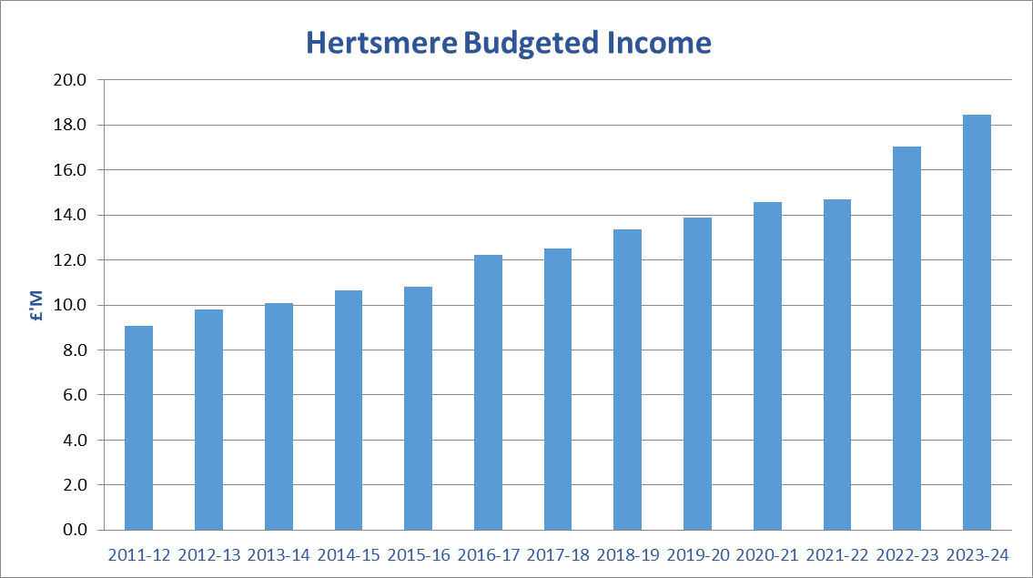**Chart 1 – Income Generation 2011/12 to 2024/25**

The **Net Budget Requirement of £13.6m** is financed partly from government grant funding totalling £4.8m or 35.3% with the remaining £8.8m or 64.7% of our funding coming from local Council Tax levies.

**Draft budget 2024/25**

The draft budget for 2024/25 as set out below shows the gross budgeted expenditure and income by service area (inclusive of housing benefit) and amounting to a net service budget requirement of £12.9m. The corporate budgets, which are held separately, include a central contingency budget, audit fees and banking charges and general expenditure as well as budgets that are yet to be allocated to specific services including a proposed staff pay award for 2024/25 of 4%, which is still subject to approval. This results in a total **Net Budget Requirement** **of £13.6m**, which must be balanced by an equivalent level of funding.



**Government funding**

Around **£4.8m of the 2024/25 net budget requirement is funded by government grants** which are based on the Government’s assessment of need and our ability to raise tax locally. This is made up of **£3.5m from Business Rates**, collected locally but distributed nationally. Currently we collect around £50m in business rates per annum and pay the majority of this over to Central Government by way of a tariff which is then redistributed nationally via the Government’s national funding formula.

**We will receive a further £1.3m through other government grants** including £0.6m from the Revenue Support Grant (RSG), services grant and New Homes Bonus. The remaining £0.7m will be received through a funding guarantee that is intended to provide a funding floor for all local authorities, so that no local authority sees an increase in its Core Spending Power that is lower than 3% before local assumptions on council tax rate increases. This funding guarantee is however around £0.1m lower than we had anticipated due to the Government’s assumptions around growth in our Council Tax Base which is greater than actual growth. We have challenged the Government’s growth assumptions through the statutory consultation process.

Our government grant funding now represents around 35.3% of our net budget requirement and has stabilised at this level over the past few years following the end of austerity, a period during which we had seen a significant reduction in our general government grant funding.

Back in 2011/12, general government funding accounted for around 50% of our total funding compared to 32% for 2024/25, which means that the cost of providing our services has fallen increasingly on council taxpayers. In 2024/25, 65% of our net budget requirement will now be funded from local Council Tax levies compared to just 50% in 2011/12. The movement in funding is shown in Chart 2 below:

**Chart 2 – Change in funding 2011/12 to 2024/25**

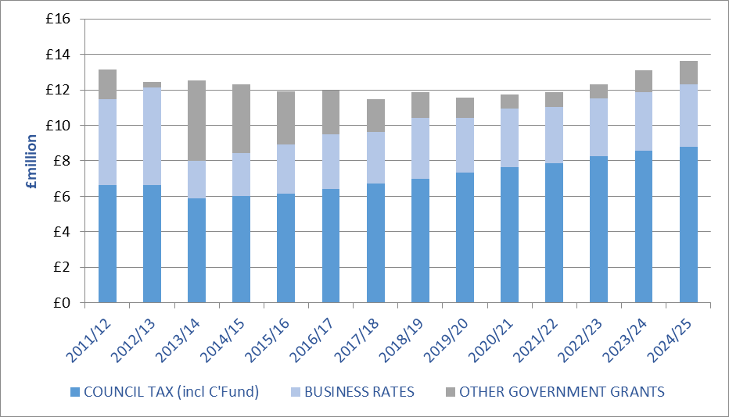

**Council tax**

Although you pay all of your council tax to us at Hertsmere Borough Council, the share that we keep is just 10%. The majority share, 77%, goes to Hertfordshire County Council; the police receive 11% and the parish and town councils two per cent. The county council and the police are responsible for setting their own council tax.

For the coming year, we are proposing to **increase our share of the council tax bill by 2.99 per cent equivalent to £5.95 which is a rise of around 11p per week per household**. This increase when set against a backdrop of high inflation with CPI currently at 4.2% means we are seeing a real terms reduction in funds to run our services. This increase of £5.95 for the coming year, which is proposed be recommended to a meeting of the full Council on 28 February 2024, will see our share of the average council tax for 2024/25 set at £203.99, the equivalent of **just 56p per day**, for an average band D property in the borough.

Every day we provide services across the borough such as kerbside rubbish and recycling collections, housing, environmental health, local planning, car parking, leisure, culture and parks and grant funding to the charity and voluntary sector including support for Citizens Advice. Your council tax is just one of the sources of income that helps to pay for these valuable services.

Whilst we work hard to improve the cost effectiveness of the services we deliver as well as manage the increasing demand as our population continues to grow, in light of high inflation and rising costs, changes in service demand and continued funding uncertainty, the increase has been necessary to maintain the provision of front line services.

The 2.99 per cent increase which represents a year on year increase of £5.95 is below current inflation of 4.2%. Hence when cost of living is taken into account this represents a real terms reduction. An increase in council tax of up to three per cent or £5, whichever is greater, is allowed by legislation and is the amount that the Government has assumed in its spending forecasts for Local Government.

**What’s next?**

Whilst we are presenting a balanced budget position for 2024/25 we must also look to the medium term to identify our future budget requirements and how these are funded. The Council’s medium term financial plan therefore looks forward to 2027/28 and based on our current budget and funding assumptions we are forecasting a funding gap over the medium term of £0.8m.

The Chancellor’s Autumn Statement in November 2023 set out the medium-term path for public finances. His statement which responded to the Office of Budget Responsibility’s latest economic and fiscal forecasts included some key announcements for local authorities. As previously announced the Local Government Funding Reform with the Review of Relative Needs and Resources (‘Fair Funding Review’) and a reset of Business Rates growth are delayed until at the earliest 2025/26 meaning that funding beyond 2024/25 remains uncertain. The statement did however confirm that departmental budgets for the three years beyond the current spending review period (2025/26 to 2027/28) would increase by 1% per annum. The local government provisional finance settlement was subsequently announced in late December 2023, as expected included funding allocations for next year only, the sixth successive one year settlement.

We also face uncertainty in respect of our own income streams, as these are dependent on various external drivers in particular the economy and the impact locally on levels of employment, business growth and demand for services such as homelessness and affordable housing.

Therefore, given the significant financial pressures and the statutory requirement to set a balanced budget, whilst at the same time preserving as far as possible the current level of services, we are continuing to look at innovative ways of managing the funding pressures over the medium term.

Over a number of years we have adopted a more entrepreneurial approach and focused on expanding our ability to generate income as well as reducing costs by entering into partnerships with other councils, to share expertise and build resilience, as well as looking for commercial opportunities such as establishing our own subsidiaries, Elstree Film Studios and Hertsmere Developments Limited. We currently have partnerships with other local authorities for building control, CCTV, audit and anti-Fraud to name a few.

In light of the current economic conditions and other pressures on the budget, going forward, Hertsmere are aspiring to achieve financial self-sustainability. The ability to raise additional income however continues to be extremely challenging due to statutory fees and other restrictions on charging limiting Hertsmere’s ability to raise additional income from fees and charges. Hertsmere therefore needs to continue its innovative and commercial approach over the coming year and will be looking at how we can leverage the maximum return from our assets.

**Have your say**

If you would like to comment on the 2024/25 draft revenue budget please take part in our Budget Consultation by no later than 11 February 2024 to allow your comments to be considered in the final budget papers. You can find the link to the consultation at [www.hertsmere.gov.uk/budgetconsultation](http://www.hertsmere.gov.uk/budgetconsultation)