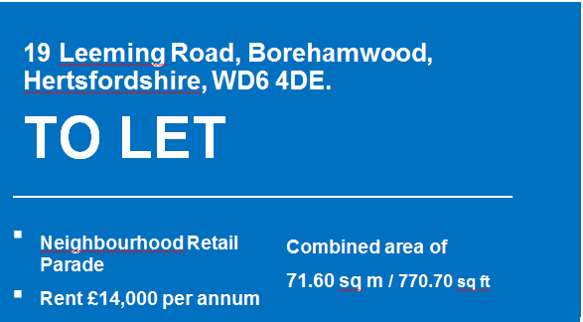

PHOTO AWAITED

TO LET
NEW LEASE
ON A NEIGHBOURHOOD SHOPPING PARADE CONSISTING OVER 35 SHOPS.

LOCATION

The premises are located on Leeming Road, which forms part of a double parade of shops, together with those on the adjacent Aycliffe Road. In total, the parade comprises 40 shop units of various sizes. The parade is located approximately one mile from Borehamwood town centre and is well served by public transport and is a well-used thorough fare and offers free on-street and off street parking. Neighbouring retailers include, The Co-op, RS McColls, Labrokes, along with independent occupiers such an off-licence, hair and beauty salons, fashion boutiques, butchers, Post Office, bakery, laundrette and dry-cleaner, a carpet retailer, bathroom and heating supplier, stationery, electrical supplier retailer. In addition, there is a dental practice, pharmacy, along with a number of cafes, restaurants and take-away businesses.

DESCRIPTION
The premises comprise a mid-terrace ground floor lock-up shop with a WC and washroom. Delivery access is via the rear of the property though a shared communal service yard and occupier parking area.
ACCOMMODATION
Shop Frontage | 6.10m | 20’ ft
Shop Depth | 12.40m | 41’ ft
Retail area | 71.60 sq m  sq | 733 sq ft
Total (excluding yard) | 71.60 sq m | 771 sq ft

LEASE TERMS
The premises are available to let, on a new lease, subject to contract:-
TERM | A five, ten or fifteen year term is available.
GUIDE RENT | £14,000 per annum
RENT REVIEWS | Five yearly upward only rent reviews.
USER | A1 use (or A2 subject to appropriate planning consent).  (Café or takeaway use ie A3 or A5 will not be permitted).
REPAIRS | The tenant is responsible for the repair and maintenance of the interior of the shop, for the shopfront, windows and all doors.
OUTGOINGS  INSURANCE | The tenant will pay all outgoings connected with the shop, including business rates, building insurance and all utility charges.  The tenant will reimburse the Council the cost of building insurance for this shop under the Council’s block policy. In 2017/18 this amounts to £ £61.93.
ALIENATION | Assignment of the whole of the premises, only with the Council’s prior written consent, subletting is prohibited.
RATEABLE VALUE  REFERENCES | £8,500. The business rates payable are £3,961(2017/2018).  Uniform Business Rates Mutiplier is (UBR) 0.466p.  Subject to satisfactory references.
RENTAL DEPOSIT | The tenant will provide a deposit equivalent to six month’s rent.
GURANTOR | Guarantor/Surety will be required.
EPC | TBC

FEES Tenant to pay Council’s reasonable legal/Surveyor fees.

VIEWING ARRANGEMENTS
To arrange a viewing please contact:-
Christian Maduekwe on Tel: 020 8207 7486 Email: christian.maduekwe@hertsmere.gov.uk
Asset Management
Hertsmere Borough Council
Civic Offices, Elstree Way
Borehamwood, Hertfordshire,WD6 1WA.
The particulars are produced in good faith, but are a general guide only and do not constitute any part of a contract. (ii) No person in the employment of the agent(s) has any authority to make or give any representation or warranty whatsoever in relation to this property. (iii) The property is offered subject to contract and unless otherwise stated all rents are quoted exclusive of VAT. (iv) Nothing in these particulars should be deemed a statement that the property is in good condition, or that any services or facilities are in working order. (v) Unless otherwise stated, no investigations have been made regarding pollution, or potential land, air or water contamination. Interested parties are advised to carry out their own investigations if required.

