**Response to TfL consultation on bus service proposals for route 298 (Potters Bar)**

**Hertsmere Borough Council**

**December 2016**

**Introduction**

Transport for London (TfL) is consulting on proposals to restructure route 298. This bur route currently runs between Arnos Grove station and Cranborne Road Industrial Estate, Potters Bar, Monday to Friday daytimes. In the evenings (from 20:00) and at weekends it runs between Arnos Grove station and Potters Bar station.

The proposal is that route 298 would be withdrawn between Potters Bar station and Cranborne Road Industrial Estate. The route would run between Arnos Grove station and Potters Bar station at all times, as shown on the map below.

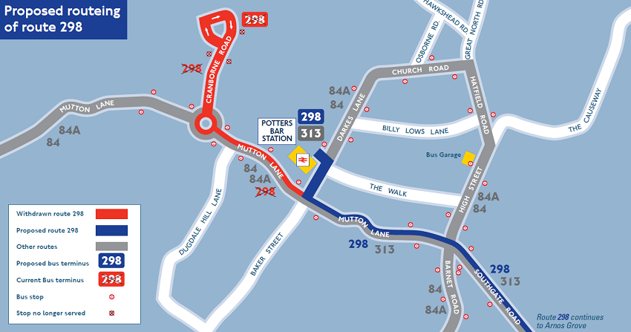

Figure 1 Proposed section of route 298 to be withdrawn, from TfL: <https://consultations.tfl.gov.uk/buses/298/>

**Hertsmere comments**

***Summary***

The council wishes to raise concerns about the withdrawal of this route. This section of route 298 is the only bus route which directly serves Cranborne Road Industrial Estate, which is a busy and thriving business hub in Potters Bar, including the Wenta Enterprise Centre. It is also the only bus route serving residents of Cranborne Road and adjoining streets.

The consultation does not include any reasons for the proposal, or evidence to show that this section of the route is not well-used, so the proposal cannot be supported. The council has attempted to locate evidence surrounding the justification for the proposed reduction in the route length, and have contacted Hertfordshire County Council who have informally provided some intormation on levels of use of this part of the route.[1]

***Detailed comments***

Hertsmere Borough Council wishes to raise concerns that the withdrawal of this part fo the 298 route will affect the ability of people running businesses and working at the Cranborne Road Industrial Estate in Potters Bar to travel to work using public transport, and to attract staff to work within their businesses.

According to an HCC report[2], the 298 route is one of 16 bus routes operated by TfL into southern Hertfordshire, 5 of which are subsidised by Hertfordshire County Council (HCC). HCC signed agreements to fund these services up to the end of financial year 2015/16, and further funding has not been agreed beyond this period.

A letter from TfL dated 2 February 2016 (attached to the HCC report) states that TfL had “not had the oportunity to to look at the routes in detail, although the current frequencies generally correlate to the usage made of them. Therefore any significant changes would have an adverse impact on those who currently use the bus service, either wholly within the county or between the Hertforshire and London Area”.[3] (our emphasis)

*Cranborne Road Industrial Estate*

Cranborne Road Industrial Estate is home to the Wenta Business Hub[4] at The Enterprise Centre, as well as numerous other successful, primarily small to medium-sized businesses.

Wenta was founded in 1983 to encourage business start-ups and to support small businesses, and the Enterprise Centre provides a mix of office space, workshops and meeting rooms for small businesses. In addition, there is also a business incubation centre[5]. This facility is currently well-occupied, with the website showing only 3 vacancies for office space of around 400m2 out of a total of around 60 offices and workshops of varying sizes.

The loss of this direct bus route is likely to have an impact on the businesses based in Cranborne Road. It could impact upon their ability to attract and retain staff, and ultimately could make the area less attractive to new businesses when units become available.

*Usage of the route*

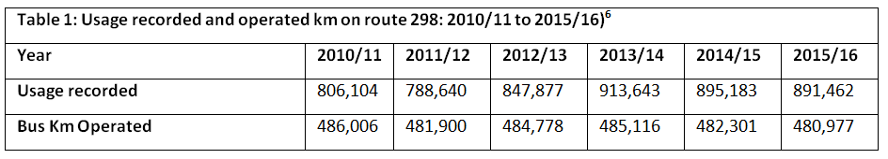Table 1 below shows that passenger numbers across the route as a whole (between Arnos Grove and Cranborne Road, Potters Bar) have remained relatively stable since 2010/11.

Hertfordshire County Council have carried out surveys[6] of the section of the 298 route and have shared some of their findings with us. This shows that in the evening peak, on the day surveyed, there were:

* 40.25 passengers travelling west towards Cranborne Road Industrial Estate (across 7 journeys) who remained on the bus after Potters Bar Station
* 26.25 people (across 7 journeys) travelling east from the industrial estate towards Arnos Grove, who remained on the bus beyond Potters Bar Station.
* the majority of passengers travelling west-bound beyond Potters Bar Station got off the bus at Cranborne Triangle, which is the junction with Mutton Lane.
* of people boarding the bus at the industrial estate on one evening peak journey, 6 passengers got off at the Triangle, while 4 remained on the bus eastward beyond the station.

These passengers would be inconvenienced by having to change buses at Potters Bar station, while those travelling to the industrial estate would have to walk about 1km from Cranborne Triangle.

The final bullet point above demonstrates that some passengers are currently using the 298 bus only to travel the relatively short distance between the Triangle and the industrial estate (about 1km), which is the only part of the route section proposed to be withdrawn which is not covered by any other bus services.

*Alternative bus links from Potters Bar Station/Darkes Lane to Cranborne Triangle and the industrial estate*

Alternative bus routes 84/84A and 398 serve the journey leg between Potters Bar Station and Cranborne Triangle. For passengers travelling on the 298 into Potters Bar from the east, these are not ideal alternatives as passengers changing to another bus would have to pay an additional fare to use the 84/84A run by Metroline or 398 run by Sullivan Buses, increasing the cost of travel for these passengers. Changing buses is not ideal and can increase journey times because the scheduled running times do not always match up, and passengers have to wait. The 84/84A runs around 4 times per hour and the 398 runs once per hour off-peak and twice per hour on-peak.

*Alternative means of travel: walking*

There is a general assumption used in planning that most people will be happy to walk up to 400m to reach a bus stop or 800m to reach a railway station.[7]

The HCC survey showed that most passengers who remained on the 298 bus after Potters Bar Station (heading west) got off at Cranborne Triangle. This is approximately 1.3km walking distance from the station, or 1km from the junction of Mutton Lane and Darkes Lane, which would still be served by the 298. Alternative bus routes do serve this part of the current 298 route, however as discussed above, separate ticketing arrangements are in place.

It is approximately 1km to the industrial estate from the junction of Cranborne Road and Mutton Lane, and about 1.6km from the railway station via a public footpath alongside the railway line (known as the ‘line path’). These distances would add time to journeys to and from work (it takes between 10 and 20 minutes to walk 1km depending on walking speed, compared to a 3-5 minute journey by bus), and the line path is unlit and unpleasant to use after dark. Additionally, not everyone is able to walk that distance.

The withdrawal of the service may have a disproportionate impact on vulnerable people (such as young people, older people, people on low incomes, disabled people and job seekers) living in the Cranborne Road area, who are most likely to rely on the bus service for essential trips into the town centre and beyond.

*Alternative means of travel: cycling*

Due to restrictions on the carriage of bicycles on buses and trains, cycling is a feasible alternative only for those people who make local journeys on the 298 within Potters Bar. If secure cycle parking was available at Potters Bar Station commuters could leave their bikes there when boarding a train or the 298 bus towards Arnos Grove. The line path is not currently dedicated as a bridleway, so cycling is not permitted, meaning that people would have to cycle along Mutton Lane, which is a fairly busy road and may be off-putting to inexperienced cyclists, particularly around the junction with Darkes Lane. Cyclists could avoid this junction by travelling via Wyllyotts Place and Laurel Avenue, but this is not signposted and is not an obvious route.

***Conclusions***

The council wishes to raise concerns about the withdrawal of this section of route 298 because it is the only bus route directly serving Cranborne Road Industrial Estate, a busy and thriving business hub in Potters Bar. It is also the only bus route serving residents of Cranborne Road and adjoining streets.

There are no reasonable alternatives to the 298 for most of the current passengers, without expecting that they either purchase additional tickets, and/or walk at least 1km from the nearest dropping-off point of the 298 or other bus routes.

As these are not acceptable options, we would ask TfL to reconsider the proposal. Alternative funding arrangements may exist which could be worked out, depending on the level of funding required to run this portion of the route, so we would be happy to work with TfL to explore potential options. In particular, the Council would be willing to enter into discussions about the possibility of allocating some funding collected locally though its Community Infrastructure Levy to support funding of the route.

1. HCC have carried out surveys of the numbers of passengers on the relevant section of the route during the evening peak – this data has not been published.
2. Petition to Withdraw the Threat of Cuts to TfL Routes in Herts: *Report of the Chief Executive and Director of Environment (*<https://cmis.hertfordshire.gov.uk/Hertfordshire/Document.ashx?czJKcaeAi5tUFL1DTL2UE4zNRBcoShgo=l2%2FIC6QfmYj4EMc1ztERt%2BqFrvGI67yZA%2BY%2Budr8OLxusbcnXBJC2w%3D%3D&rUzwRPf%2BZ3zd4E7Ikn8Lyw%3D%3D=pwRE6AGJFLDNlh225F5QMaQWCtPHwdhUfCZ%2FLUQzgA2uL5jNRG4jdQ%3D%3D&mCTIbCubSFfXsDGW9IXnlg%3D%3D=hFflUdN3100%3D&kCx1AnS9%2FpWZQ40DXFvdEw%3D%3D=hFflUdN3100%3D&uJovDxwdjMPoYv%2BAJvYtyA%3D%3D=ctNJFf55vVA%3D&FgPlIEJYlotS%2BYGoBi5olA%3D%3D=NHdURQburHA%3D&d9Qjj0ag1Pd993jsyOJqFvmyB7X0CSQK=ctNJFf55vVA%3D&WGewmoAfeNR9xqBux0r1Q8Za60lavYmz=ctNJFf55vVA%3D&WGewmoAfeNQ16B2MHuCpMRKZMwaG1PaO=ctNJFf55vVA%3D>)
3. Ibid (p.5)
4. Wenta: Potters Bar, The Enterprise Centre: <http://www.wenta.co.uk/potters-bar-the-enterprise-centre>
5. My Incubator: <http://www.myincubator.co.uk/>
6. Passenger numbers have been extrapolated because 4 out of the 7 journeys were covered by the survey. The survey showed 23 passengers over 4 west-bound journeys and 15 passengers east-bound over 4 journeys.
7. Getting there: How sustainable transport can support new development: <http://www.bettertransport.org.uk/sites/default/files/research-files/Getting_there_final_web_0.pdf>