
Hertsmere Borough Council

CARBON REDUCTION GRANT
APPLICATION FORM 2026/27

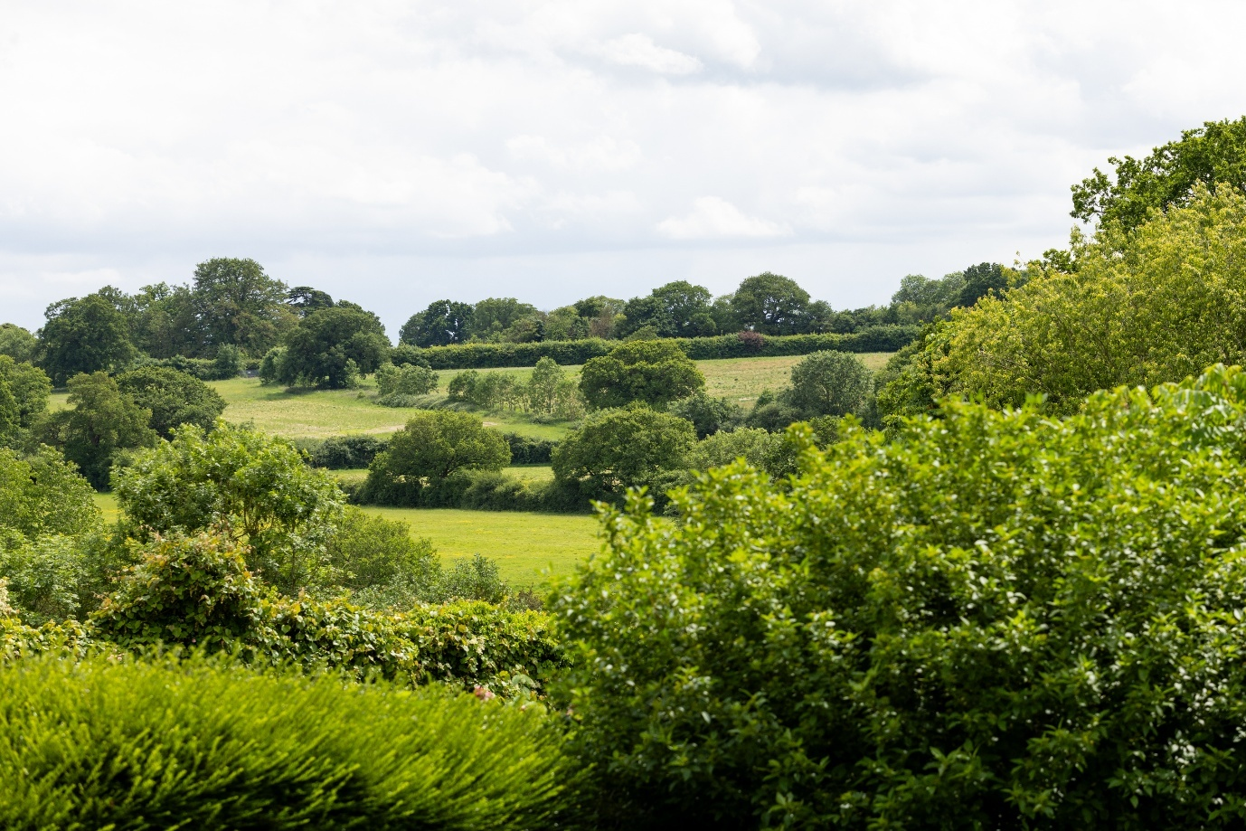
Please ensure you read the Guidance Notes available on the website prior to completing this form. Submitting an application does not guarantee funding. You will be contacted once your application has been considered.

ORGANISATION DETAILS

1 Details for your organisation
Name of organisation to whom the grant will be paid:

Main contact person for this application:

Role:

Address:

Telephone number:

Email address:

Tell us about your group – what are your aims, where do you meet and who are your clients/members?

If applicable, please provide details of any membership fees or charges to your members / users:
Is there any provision for those who cannot afford to pay the fees/charges?
Yes No N/A If yes, please give details:

- Which of the following best describes your organisation:
Please also submit a copy of your organisations constitution or aims.

Registered Charity - If yes, please give number:
Voluntary / community organisation
Social enterprise / CIC / CIO
Other (Please describe):

- If you have received any financial assistance (WIIS, community grant, celebration grant or partnership funding) from Hertsmere Borough Council in the last three years please give details of the financial year, amount and purpose for which it was given:

Financial Year | Amount Received | Purpose

- What was your income and expenditure in the last financial year?
Please also submit a copy of your organisations latest full year accounts with the application. If you are a new organisation, please provide a business plan showing your projected costs and expected income for at least one year.

Year ending (date)
Opening cash balance | £
Closing cash balance | £
Income for the year (include any grants awarded) | £
Expenditure for the year | £
TOTAL closing balance at end of year (including reserves) | £

- Are there any explanatory comments you wish to make about your organisations finances, including details of any commitments, requirements or plans that impact on closing balance?
PROJECT DETAILS

- What will the funding you are applying for be used for?
Provide details of your project including where it will take place, who will benefit/participate, etc.

Amount requested | £
Please provide details of your project:

- Please provide information on how the project will be funded
£
Total Cost of project/event
Amount Requested from Hertsmere Borough Council
Amount remaining:

7a. How will the remaining balance be funded?
Funding source  (including from your own funds) | Status  (received, approved, pending, outstanding) | £
TOTAL
(should equal the amount remaining above)

- How will you spend any money you are awarded?
(A summary under headings will suffice)
Item/Event | Cost

- How will you ensured best value for money?

- How many people will benefit from this grant? Please provide your best estimate.

 | Hertsmere residents | Non-Hertsmere residents | TOTAL
Adults over 60
Adults 25 – 59
Young people 15 – 24
Children 0 – 14
TOTAL

- How will your project reduce carbon emissions? (For example: saving energy, renewable energy, planting trees)

- Estimated annual and lifetime carbon savings (required):
- We have estimated this: __________ tonnes CO₂ eq.
- We are not sure, but here is our best explanation:

- How did you estimate the savings and how will you monitor them?

- Would this project go ahead without this funding? Please explain your answer:

- How will your project benefit the community? (e.g. lower bills, improved wellbeing, community use)

- What additional environmental benefits will your project provide? (e.g. improved biodiversity, better air quality, flood reduction/climate resilience, greener spaces, reduced consumption)

- Are you willing to provide a short final report and an annual impact report for 3 years? Yes/No

- How will the benefits of your project continue after funding ends?

- What are the main risks to your project and how will you manage them?

- Are you a Member or employee of, or are you to your knowledge related to a Member or employee of Hertsmere Borough Council.

Yes No

If yes, please give details: ………………………………

- Declaration
I declare that the information supplied in this request is true and correct. I can confirm that my organisation has a bank account in its name with at least 2 signatories. I also confirm that any grant money received from Hertsmere Borough Council will be used for the purposes described in this form.

Signed: ………………………………………………………….. Date: ………………..

Print Name: …………………………………………….…………………………………

Please tick the box if you would be happy to receive other relevant information which we feel would be useful to you as an organisation or your beneficiaries.

Data Protection
The information you have provided is needed for the administration of this service only. The information you provide will be held in confidence and stored securely.
Hertsmere Borough Council will share this information with the Grants Panel who determine the grants on your behalf. Your information will not be used for any other purpose than described and will be securely destroyed upon completion in line with legislative requirements.

Please email this form along with the supporting documents to grantapplications@hertsmere.gov.uk or send a hard copy version to Hertsmere Borough Council, Civic Offices, Elstree Way, Borehamwood, Herts, WD6 1WA, attention: Hannah Oliver, Partnerships and Community Engagement, telephone: 020 8207 2277.

APPLICATION CHECKLIST

Be sure to read the guidance notes before you start your application.

ALL APPLICATIONS
- A copy of your constitution (unless you are a registered charity)
- A copy of your equalities policy
- A copy of your organisation’s latest full year accounts or in the case of a new organisation, projected costs and expected income for at least one year
- If you work with children, or older or vulnerable adults a copy of your safeguarding policy (Evidence of DBS checks should be available on request)

