
Hertsmere Borough Council

2026/27 DRAFT BUDGET SUMMARY


Background

At its meeting on 14th January 2026 our Cabinet considered the draft revenue budget for the next financial year, 2026/27. During the debate the Cabinet acknowledged the outcome of the Fair Funding Review and the resulting three year financial settlement that has been better than could have been expected and announced some amendments to the proposed budget investing additional resources into priority frontline services including Community Inclusion, Community Safety, Anti-Social Behaviour and Street Cleansing bolstering these areas of community priority. Subject to these revisions the Cabinet recommended the draft revenue budget 2026/27 for consultation, before we present the final budget to a meeting of the Full Council for approval on 25 February 2026. As a key stakeholder we would like to seek your views on our budget proposals.

This document provides a summary of some of the key elements of our draft revenue budget for 2026/27. The detailed draft revenue budget report can be found on the 14 January 2026 Cabinet agenda pages of our website via the following link: Agenda for Cabinet on Wednesday, 14 January 2026, 6.00 pm

Setting the 2026/27 revenue budget

The 2026/27 revenue budget has been set following the long awaited Fair Funding Review which has reset Government funding across local government, the first funding review in 12 years, and has provided funding certainty over the next three years.

The budget process, which begins in the spring each year, considers the Council’s current funding position, takes into account various factors that can potentially impact on the budget requirement including changes in service delivery, service need and legislative changes as well as other internal and external risks and uncertainties.

In setting the 2026/27 budget we have therefore considered many factors. Some of the main considerations are in relation to:

- Government funding – The Fair Funding Review has reassessed local authority funding on a needs basis. The new funding formula has simplified local authority core spending power and provided funding certainty over a three year settlement period. Protections have been built into the new formula to ensure no local authority loses more than 5% of their existing funding. Hertsmere are one of 68 authorities on the negative funding floor, albeit our provisional financial settlement has been determined against a higher than expected base funding level.
- Government Policy – The Government’s Devolution agenda and the government led programme of Local Government Reorganisation (LGR) in place to support it means that local authorities in a two tier structure such as Hertfordshire will need to form new single tier unitary authorities by April 2028. All the Hertfordshire Authorities have worked together to develop a submission to Government setting out our proposals for LGR across the County.
- Economy and Cost of Living – Whilst the economy has been recovering over the past couple of years the impact of recent economic turmoil continues to impact on household budgets impacting our residents and staff as well as impacting on service costs and the ability to generate income through fees and charges.
- Staff Pay, Recruitment and Retention – With the increased cost of living, staff expectations for a significant pay increase remain high. A 3% pay award was agreed for Hertsmere staff for 2025/26 which fell slightly behind the National Joint Committee (NJC) pay award agreed for the wider sector of 3.2%. Recruitment and retention continues to be an issue across the Council due to Hertsmere’s high housing costs and our close proximity to London. The draft 2026/27 budget includes provision for a 3.0% pay award.
- Homelessness – Homelessness pressures continue to rise with homelessness approaches to the Council doubling since 2019/20. However due to an investment in prevention work, the Council has not seen this increase reflected in the number of households in temporary accommodation.
- Local Plan – The Council does not currently have an up-to-date Local Plan and only has a low level of housing supply, and therefore is at risk of speculative applications for development. The adoption of a Local Plan will assist the Council in directing growth as well as supporting infrastructure to the appropriate locations with the input from statutory partners and the local communities. Work on a new Local Plan is well underway.
- Income – whilst budgeted income from rent, sales, fees and charges and investments is set to rise from £22.1m in 2025/26 to £24.1m in 2026/27, the majority of income budgets are subject to external factors, such as supply and demand, market forces and the general state of the economy and competitiveness of the market.
- Council Tax – in line with the Government’s funding formula this draft budget proposes a Council Tax increase of 2.99% equivalent to £6.20 for the year 2026/27 for an average band D property.

Balancing the budget

Setting a “Balanced Budget” for the year ahead is a Statutory Requirement for us. A balanced budget is where our “Net Budget Requirement” is matched by an equivalent level of funding.

Our gross expenditure budget for 2026/27 amounts to £61.1m of which £18.7m relates to housing benefit payments. Housing benefit payments are in the main funded by the Department for Work and Pensions through the housing benefit subsidy grant. Our gross income budget is £42.8m inclusive of the housing benefit subsidy.

Our gross expenditure is partially offset by the income we generate and for 2026/27 we are budgeting to raise around £24.1m in income, the majority of which comes from rental income from our property portfolio. We also raise income through fees and charges for some specific services, earn income from our investments and receive some specific grant funding for example for homelessness prevention. Our commercial approach to income generation has helped us to protect our frontline services over a prolonged period, particularly when funding was reducing, there were significant cost increases as well as rising service demand. As such, since austerity measures were introduced by the then Government back in 2010, our income has been rising year on year to support our “Net Budget Requirement” and in total has now risen by around 165% or £15.0m over the past 17 years, as shown in Chart 1 below:

Chart 1 – Income Generation 2012/13 to 2026/27

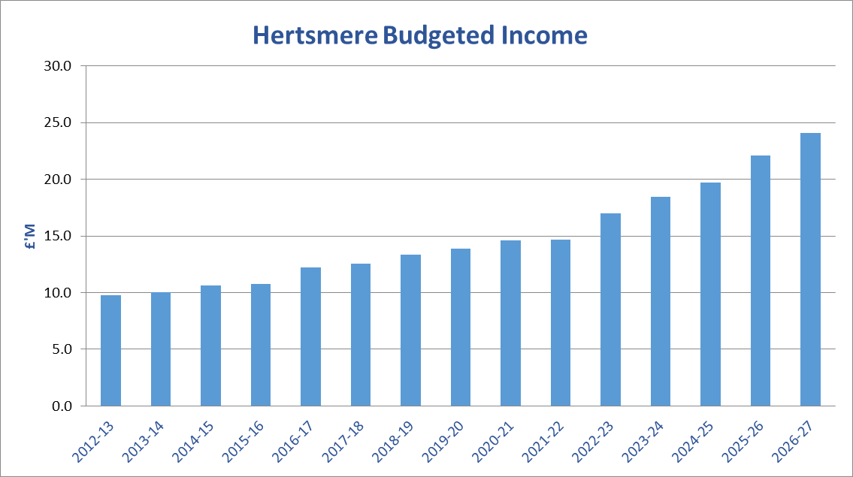

After allowing for gross expenditure of £61.1m and income generated by the Council of £42.8m, our “Net Budget Requirement” for 2026/27 is now £18.3m.

Government funding
The Fair Funding Review has re-assessed local authority need taking into consideration factors such as deprivation in determining a local authority’s core spending power requirements. The purpose of the Fair Funding Review was to refresh the methodology, last reviewed 12 years ago, for distributing a fixed pot of funding between all English local authorities.

The outcome of this re-assessment has been delivered through the provisional finance settlement, announced on 17 December 2025, which set out a multi-year financial settlement for 2026/27 to 2028/29 providing funding certainty over this period.

Any such funding review will always result in winners and losers, hence the Fair Funding Review has included protections to prevent any authority losing more than five per cent of their existing funding. Hertsmere were one of 68 local authorities who have been protected by this negative funding floor which will now reduce by five per cent compared to 2025/26, phased over the next three years. This is however from an elevated funding position which included retained business rates growth that had previously sat outside of core spending power and was not expected to be retained going forward. Hertsmere have therefore fared better following the funding review than had been expected.

Hertsmere’s core spending power, which includes core Government funding, specific grants and Council Tax levies as specified by Government, for the next three years is set out below against a restated base position for 2025/26 for comparison:

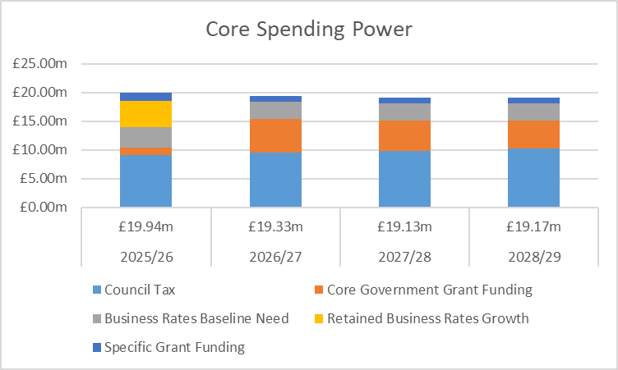

Council tax

Although you pay all of your council tax to us at Hertsmere Borough Council, the share that we keep is just nine per cent of the total amount you pay. The majority share, 77%, goes to Hertfordshire County Council; the police receive 12% and the parish and town councils two per cent. The county council and the police are responsible for setting their own council tax.

For the coming year, based on the Government grant formula, we are proposing to increase our share of the council tax bill by 2.99 per cent equivalent to £6.20 which is a rise of around 12p per week per household. This increase, which is proposed to be recommended to a meeting of the full Council on 25 February 2026, will see our share of the average council tax for 2026/27 set at around £216, the equivalent of just 59p per day, for an average band D property in the borough.

Every day we provide services across the borough such as collecting approximately 100,000 household waste and recycling bins weekly, housing services, environmental health, local planning, car parking, leisure, culture and parks, community safety and grant funding to the charity and voluntary sector including support for Citizens Advice. Your council tax is just one of the sources of income that helps to pay for these valuable services.

Whilst we work hard to improve the cost effectiveness of the services we deliver as well as manage the increasing demand as our population continues to grow, in light of high inflation and rising costs, changes in service demand and continued funding uncertainty, the increase has been necessary to maintain the provision of front line services.

An increase in council tax of up to three per cent or £5, whichever is greater, is allowed by legislation and is the amount that the Government has assumed in its spending forecasts for Local Government.
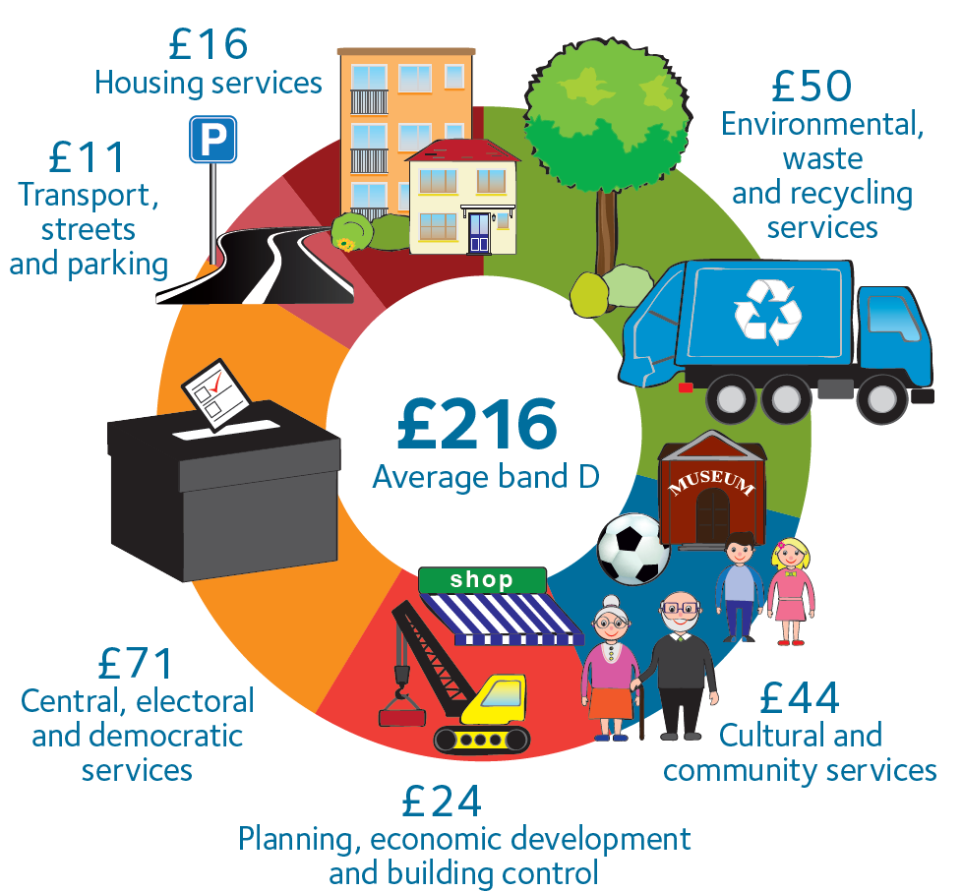
Draft budget 2026/27
The draft budget for 2026/27 as set out below shows the gross budgeted expenditure and income by service area and amounting to a net service budget requirement of £14.2m. The corporate budgets, which amount to £4.0m, are held separately and include a central contingency budget, audit fees and banking charges and general expenditure as well as budgets that are yet to be allocated to specific services, including a proposed staff pay award for 2026/27 of 3% and proposed service improvements that were announced at the Cabinet meeting on 14th January 2026 in relation to Community Safety, Street Cleansing, Cultural Services and Ward Improvements.

This results in a total “Net Budget Requirement” of £18.3m, which is financed partly from core government grants totalling £8.9m with the remaining £9.3m of our funding coming from local Council Tax levies as discussed above.

What’s next?

Through a rigorous budget scrutiny process and as a result of a better than expected multi-year financial settlement we have been able to balance our budget not just for next year but also over the medium term to 2028/29.

We must however be mindful that whilst we now have a balanced budget position based on our existing priorities, that we continue to face uncertainty in relation to our service costs as well as our own income streams, which are dependent on various external drivers in particular the economy and the impact locally on levels of employment, business growth and demand for services such as homelessness and affordable housing. As such we will continue to undertake a stringent annual budget process challenging the way we deliver our services to ensure “Value for Money” for our community.

Over a number of years we have adopted a more entrepreneurial approach and focused on expanding our ability to generate income as well as reducing costs by entering into partnerships with other councils, to share expertise and build resilience, as well as looking for commercial opportunities such as establishing our own subsidiaries, Elstree Film Studios and Hertsmere Developments Limited and joint venture housing stock company Hertsmere Living Limited. We also currently have partnerships with other local authorities for building control, CCTV, audit and anti-Fraud to name a few. We intend to continue our innovative and commercial approach over the coming years and will be looking at how we can leverage the maximum return from our assets.

We will also continue to work alongside Hertfordshire County Council and the other Hertfordshire districts to progress the Local Government Reorganisation agenda and we await the Government’s response to our recent submission.

Have your say

If you would like to comment on the 2026/27 draft revenue budget please take part in our budget consultation by no later than 15 February 2026 to allow your comments to be considered in the final budget papers. Here is the link to the consultation-
Budget consultation 2026/27.

