

Hertsmere Borough Council

Corporate Procurement Strategy

**2025-2028**

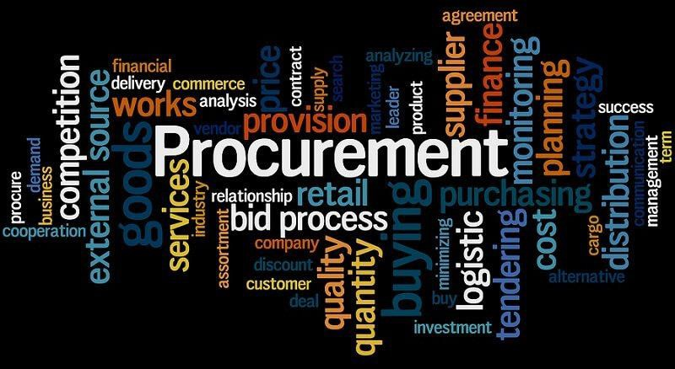

**Foreword**

This is an exciting time for Hertsmere Borough Council to be launching a new procurement strategy with the Procurement Act 2023 coming into force in early 2025. Hertsmere Borough Council spend approximately £14m every year on goods, works and services. Value for money and high quality services are at the heart of our procurement delivery. The new act reforms the existing procurement rules focusing on cutting red tape and supporting innovation, improving transparency by creating a fully open and transparent system meaning everyone has access to public procurement data, it also simplifies the process of working with the public sector, supporting more SMEs to bid for contracts.

This strategy strengthens Hertsmere in its vison to deliver better futures by enabling an efficient and effective service, making a difference to work together with our communities, creating high quality solutions, delivering social value and embracing new ways of working. This includes finding new ways to generate income, manage resources effectively, and invest in projects that benefit the community long-term. Procurement will play its part in supporting our existing suppliers through good contract management and encouraging new suppliers to tender for up and coming opportunities.

This procurement strategy links with the Local Government Association’s (LGA’s) National Procurement Strategy and brings together key considerations. This links into the Council’s wider objectives, many of which are highlighted within. Naturally as our landscape continually changes, the strategy will be updated periodically to reflect today’s evolving environment.

The Council has implemented the co-operative party charter against modern slavery and expects transparency from all suppliers doing business for them. There are checks in place through the procurement process and we will continue to develop our processes to eliminate modern slavery in the supply chain.

In 2019, Hertsmere Borough Council declared a Climate Emergency and committed to achieving carbon net zero as soon as possible and no later than 2050. Many sustainable and carbon reduction benefits can be achieved through supplier engagement before the procurement process begins. The Council will work with the market to understand the benefits and opportunities not only for Hertsmere Borough Council but to society, the local economy and minimising damage to the environment.



Councillor Chris Shenton

Finance and Budget Portfolio Holder

# Introduction

* 1. The aim of this strategy is to set out a clear framework for undertaking procurement exercises throughout the authority, one which ensures best value through our external spend, and reflects and promotes the wider aims of Hertsmere’s Vision 2024-2027.

## Who is this Strategy for?

* + - **Council Members** – so that they can guide, challenge, and review the way that procurement is applied at the Council
    - **Hertsmere Borough Council Senior Management** – so that they can manage their department’s compliance to principles and actions outlined in the Strategy
    - **Corporate Procurement Department** – to support aims and objectives of the Council as outlined in the Strategy shaping procurement processes across the Council
    - **Current & Potential Suppliers (including local suppliers, small medium enterprises, charitable, voluntary and community sectors)** – so that they can understand the direction of procurement at the Council
    - **Customers** – so that they can comment, input and see the direction of procurement at the Council
    - **Partners** – to ensure that the Council’s policies and strategies are aligned to procurement aims, goals and initiatives
    - **Other Stakeholders** – for information to other Council’s, groups with an interest in procurement in the Council, Government Agencies, Trade Unions and other relevant agencies

# Mission and Vision Statement

**Our Mission** – is to provide efficient, transparent and strategic procurement services that support the local authority’s growth, sustainability and add value through continuous improvement.

**Our Vision** – we will put procurement at the heart of a sustainable economy to maximise value for our communities by delivering commercially effective and compliant procurement services.

1. **Strategic Importance**

## Hertsmere’s Vision 2024-2027

Hertsmere’s Vision 2024-2027 sets out four sets of strategic priorities.

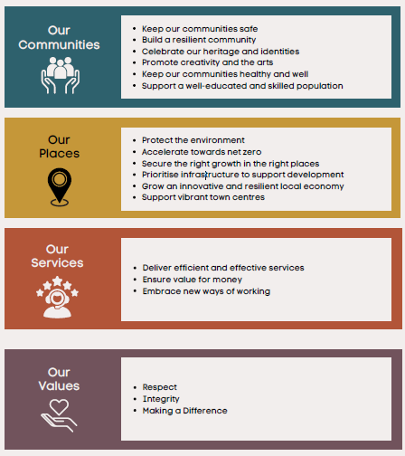

The Council recognises that procurement has a major role to play in supporting the delivery of the strategic priorities. The Corporate Procurement Strategy is aligned with the four sets of strategic priorities and with other Council policies and procedures they work together to form the vision “delivering better futures”.

## 3.2 Regulatory Framework

The key internal policies, procedures and strategies that link to the Corporate Procurement Strategy are:

* + - Contract Procedure Rules
    - Financial Strategy
    - Finance Procedure Rules
    - The Constitution
    - ICT Strategy
    - Climate Change and Sustainability Strategy
    - The Anti-Fraud and Corruption Strategy
    - Modern Slavery Charter
    - Risk Management Strategy

Procurement activity must also comply with the relevant legal requirements and legislation which include:

* + - The Public Contract Regulations 2015 (for procurements undertaken pre 24/02/25)
    - The Procurement Act 2023 (for procurements undertaken post 24/02/25)
    - Transfer of Undertakings (Protection of Employment) Regulations 2006 as amended by the Collective Redundancies and Transfer of Undertakings (Protection of Employment) (Amendment) Regulations 2014.
    - Equality Act 2010
    - The General Data Protection Regulation (GDPR) 2018
    - Social Value Act 2012

## Strategic Importance

The Council acknowledges that procurement has a major role to play in delivering efficient, effective and high quality front-line services. It also endorses the potential of partnership working with other public bodies and voluntary organisations to deliver services, and as such, will actively seek to work in partnership and promote partnership where it is feasible; it offers the Council value for money and aligns with the strategic priorities.

## Strategic Objectives for Procurement

The Council’s strategic objectives for procurement are to:

* + - Contribute to the realisation of the Council’s strategic priorities and support the achievement of the key objectives.
    - Achieving value for money in the procurement process, to result in the most advantageous decisions being made to benefit our community to strive for continuous improvement in service delivery through effective contract management.
    - Incorporate sustainability into the procurement process to support Hertsmere’s ambition to become carbon neutral as soon as possible.
    - Be guided by the principles of the National Procurement Strategy 2022 and the National Procurement Policy Statement and put procurement at the heart of our community through specifying additional social value and engaging with local companies and voluntary sector groups.
    - Conduct procurement activities on the basis of the whole life cost of a project including initial capital cost, operational, repair, and maintenance, upgrade and disposal costs.
    - Manage procurement projects robustly so that they are successful and the intended benefits are realised.
    - Adopt partnering as the preferred procurement strategy for all major projects.
    - To ensure compliance with all legislative and internal requirements including the Public Contract Regulations 2015/the Procurement Act 2023, Contract Procedure Rules and the Financial Procedures.

The Council will:

1. Consider the impact on the community and residents of the Borough as part of any procurement process.
2. Ensure that goods, works and services are purchased on the basis of whole life cycle cost and the best offer to the Council.
3. Support and encourage innovative approaches to procuring goods, works and services through the relevant regulatory framework.
4. Ensure relevant and suitable key performance indicators are included in contracts which can be contract managed appropriately.
5. Ensure all tender opportunities are advertised on contracts finder and the Supply Hertfordshire website, if of a covered procurement (high) value contract (PCR 2015/PA 2023) then also on the Find a Tender website. We will make local suppliers aware of these portals so they can bid for our contracts.
6. Recognise the benefits of social value and where possible include evaluation criteria to encourage positive outcomes for the community

based on the principles of social value. If contracts are of a high value and long term then the Social Value Portal will be used.

1. Support businesses wanting to bid for Council contracts by promoting Hertsmere’s Selling to the Council Guide.
2. Support the Council’s carbon neutral ambition by including sustainable evaluation criteria in all procurement activity where possible which may be within the Social Value Portal if high value.

## The Procurement Cycle

The procurement cycle illustrates the process requirements of acquiring goods, works and services and identifies the key stages needed to deliver a successful procurement project from initiation through to contact conclusion.

[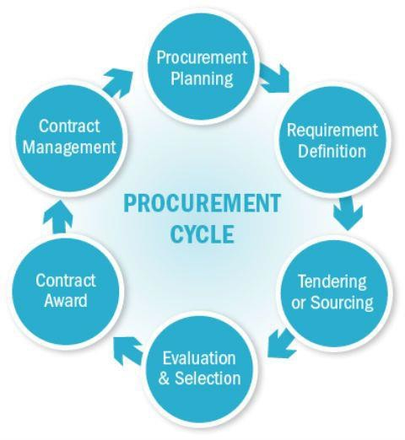](https://www.google.co.uk/url?sa=i&url=https%3A//in.pinterest.com/pin/414331234441956349/&psig=AOvVaw08faxdyxDhT3RPFEhffI1d&ust=1592590871045000&source=images&cd=vfe&ved=0CAIQjRxqFwoTCLi5sIr9i-oCFQAAAAAdAAAAABAh)

# Position Statement

The Council operates a mix of centralised and devolved procurement.

The procurement section reports to the Head of Finance and Business Services and is responsible for the procurement strategy, policies and issuing advice on procurement. The procurement section is also responsible for project managing

larger procurement exercises with the smaller procurements being devolved to the service areas.

The Councils intranet contains detailed procurement information including tender and contract templates and guidance for service areas to conduct their own procurement projects. The procurement section also deliver training to staff to support all levels of projects being undertaken.

# Procurement Themes

## Value for Money

Procurement of services, supplies and works will be founded upon value for money for the residents of Hertsmere, having due regard to propriety and the Council’s legal obligations. Value for money as a contract criterion will be defined as the optimum combination of whole life cycle cost and quality (or fitness for purpose) to meet the customer’s requirement.

It is essential to adopt processes to secure best value, the Council is therefore:

* + - driven by optimising output and results
    - driving down the costs of goods, works and services procured
    - challenging the status quo in order to continually improve the way in which we procure and commission goods, works and services
    - balancing quality and cost
    - using competition to obtain best value
    - valuing innovation and creativity
    - being transparent and accountable
    - working with other organisations and/or partners in order to achieve value for money and maximise economies of scale for routine supplies.
    - recognising the benefits of social and community value

## Social Value

Compliance with the requirements of the Social Value Act 2012 is mandatory and requires the Council to take into account economic, social and environmental well-being in connection with public sector contracting arrangements (where appropriate).

The Council seeks to make a positive contribution towards social inclusion, securing improvements to the environment and minimising environmental impact through its purchasing activity. Evaluation criteria involving social considerations will be used as part of the tender evaluation process (where appropriate) and for projects of high value the Social Value Portal will be used. If a contract is awarded with Social Value this needs to be contract managed

along with other contractual requirements. If the contract has been awarded using the Social Value Portal, progress data will be input on a quarterly basis by the successful contractor.

## Ethics and Probity, Code of Practice

In all their dealings, Members and Officers will preserve the highest standards of honesty, integrity, impartiality and objectivity. This includes compliance with the Council’s Constitution, Contact Procedure Rules, Financial Procedures, the Member Code of Conduct and the Officers Code of Conduct. In addition, any officer undertaking a procurement activity shall comply with the substance of the Chartered Institute of Procurement and Supply Code of Conduct.

All those involved in the Council’s procurement and selection process will:

* + - At all times, fully comply with all the legislation to which they are subject
    - Use an appropriate process conducted in an honest and ethical manner
    - Maintain the Council’s business free from the adverse effects of fraud and corruption
    - Positively encourage prevention ensuring conflicts of interest are avoided or managed
    - Take all appropriate actions where fraud and corruption are suspected

## Data Transparency

The Council maintains a register of all current contracts which is published on the Councils website on a quarterly basis in line with The Local Government Transparency Code 2015. Additional transparency requirements will be managed under the Procurement Act 2023 including a requirement to publish notices throughout high value procurements and compliance with payment terms.

## Competitive and Fair Procurement

The Council’s Contract Procedure Rules detail the process of competitive tendering. A fair and transparent process where the most advantageous offer is accepted promotes economy, efficiency and effectiveness in the Council’s expenditure. Competition enables better solutions and encourages suppliers to produce their best offer.

The Council is committed to using the service provision which is most likely to deliver the best value for the residents of Hertsmere. This may be a “mixed economy” for example part direct provision and part contracted out or delivered in partnership, a shared service or a joint Local Authority provision. Service providers may be procured from public, private, voluntary and community sectors. A business case may be undertaken to ascertain the most appropriate route to procure.

## Sustainability/Achieving Net Zero

The Council recognises that it has a vital role to play in furthering sustainable development and addressing the issue of climate change and carbon reduction through its procurement of goods, works and services. Procurement decisions have a major socio-economic and environmental implication, both locally and globally, now and for future generations.

In 2019, Hertsmere Borough Council (HBC) declared a Climate Emergency and committed to achieving carbon neutrality as soon as possible and no later than 2050.

Our first consideration should be - do we need to buy at all? if we do then we should consider how to achieve carbon neutrality in the procurement and through the supply chain. Some of the following considerations need to be taken when going through the procurement process. How do we get our suppliers to focus on;

* + - Reducing consumption
    - Minimising waste
    - Switching to renewable forms of energy
    - Switching to sustainable forms of transport
    - Implementing principles of circular economy
    - Buying and consuming local produce
    - Protecting and enhancing greenbelts and biodiversity
    - Building climate change resilience.

These considerations will need to be specified and evaluated as part of a procurement exercise. It is possible for targets to be set as performance measures throughout the course of a contract. If key performance indicators are set, they will need to be carefully contract managed throughout the term of the contract. Not all of the considerations will be relevant to every procurement exercise and pre-market engagement with suppliers may help to understand what is and is not possible.

## Competency Standards and Training

The Council shall establish standards of competency in procurement and contract management and shall take steps to ensure a structured approach to learning, training and development of officers and Members across the Council who have procurement related responsibilities. Underpinning the standards will be compliance with the relevant codes of conduct and established procedures as set out in 5.3.

## Business Case and Options Appraisal

A business case will be prepared for consideration before embarking on any project designed to introduce a new model of service delivery.

The business case will consider the following criteria:

* + - Strategic Fit with Council Priorities
    - Value for Money
    - Affordability
    - Achievability
    - Commercial Viability
    - Risk Management
    - Legal Implications
    - Environment and Sustainability
    - Social Value

High expenditure and risk items are strategic projects and for these the Council will adopt the partnering approach where possible and appropriate. This will involve a sound business case, proper planning and resourcing and effective project and risk management reviews.

For low expenditure, low risk items the Council will lever the collective buying power of the various service areas of the Council and will result in the letting of framework contracts or working with other organisations on a consortia basis.

## Relationships and Partnering

Partnering supports the delivery of better services to the residents of the Borough. Through the creation of sustainable partnerships between Councils and other public bodies, better value can be driven through combined purchasing power; avoidance of multiple procurements and the use of wider experience.

We will seek to achieve partnering through the building of multi-organisation working groups and aligning strategies to go to the market together through joint framework agreements enabling economies of scale to be achieved.

It is important to choose a partner who shares similar values and has a compatible culture as the quality of the service may depend as much on the values of the organisation and its staff as on the performance and standards written into the contract.

Commercial Partnering Contracts will also move to open book accounting methods of payment and should include a series of key performance indicators.

## Contract Management

Contract Management is concerned with the continuous review and management of the contractual terms and/or service level agreement/specification secured through the procurement process to ensure the outcomes agreed are actually delivered by suppliers or partners. Managing the contracts and relationships with our delivery partners is imperative to ensure that:

* + - The strategic priorities agreed at the outset are delivered in a cost effective and timely manner
    - Non-compliance or variation is identified early for escalation and resolution
    - Risks and costs are managed
    - Reviews are undertaken and lessons learnt are used to inform the renewal procurement process to enable continuous improvement

Some high value contracts will require public notices to be published throughout the contract management process as part of the Procurement Act 2023.

## Risk Management

Procurement is subject to risk and uncertainty. The risk that procurement outcomes will not match the initial objectives needs to be recognised from the outset and suitable risk management approaches should be utilised. This may involve consultation with various departments at varying stages in the procurement cycle.

Commercial risk to the organisation should be managed effectively through best and robust procurement practice. The procurement department is able to facilitate appropriate management.

Risks should be managed and reside with those most able to effectively manage them. This may require the supplier to accept risk within formal contract terms and conditions.

## E-Procurement

E-procurement systems streamline all aspects of the purchasing process. All the Council’s procurement activity should be processed via the appropriate electronic financial or e-tendering system.

The Council processes transactions electronically whenever possible. E- procurement solutions that provide efficiencies will be implemented when appropriate to deliver lower transaction costs, create an audit trail, reduce off contract spend and minimise paperwork therefore providing efficiencies and environmental benefits.

Suppliers are encouraged to register on the Council’s e-tendering system Intend through the Supply Hertfordshire website and the Central Digital Buying platform which will form part of the Procurement Act 2023.

The procurement department will ensure guidance, support and training is provided where necessary and will facilitate the procurement process via the e- tendering system, Intend.

## TUPE and Workforce Issues

The Council is committed to being a good employer and to a quality, well- motivated workforce fully enabled to deliver effective services to the customer. Staff will be consulted at all relevant stages of a procurement project and especially in situations likely to involve a transfer of staff.

The TUPE Regulations apply to transfer situations and in such situations the Council will use its best endeavours to facilitate the admission of the service provider or contractor to the local government pension scheme.

## Social and Economic Development

The Council is committed to promoting a strong local economy by providing high quality information and advice (including information on the Council’s website) and, through capacity building measures, the Council will assist local businesses, small medium sized enterprises (SME’s), charities and social enterprises to build their capacity to compete for and retain public contracts. The Council will support meet the buyer events to maximise the opportunities for all organisations that would like to do business with the Council.

The Council recognises that SMEs in the right circumstances offer better value for money than larger suppliers. For instance they may bring greater competition to the marketplace, have smaller administrative overheads and management costs, bring innovation, respond quickly to changing requirements, be flexible and willing to tailor a product or service to meet specific customer needs, offer high quality and personal levels of service or supply specialist products and services.

SME’s may be social enterprises, that is businesses with primarily social objectives whose surpluses are principally reinvested for that purpose in the business or in the community, rather than being driven by the need to maximise profit for shareholders and owners. The Council acknowledges that their social, and often environmental objectives combined with their entrepreneurial flair can provide an excellent basis for the delivery of public services to their local community.

Furthermore the Council recognises that many voluntary and community sector organisations have certain characteristics which make them potentially better able to deliver services than either their public or private sector counterparts. These characteristics include the ability to draw on specialist knowledge and

experience, unique access to the wider community and freedom and flexibility from institutional pressures.

## Modern Slavery

Hertsmere Borough Council has a duty under section 54(1) part 6 of the Modern Slavery Act 2015 to ensure that slavery and human trafficking are not taking place in our supply chain. This Strategy provides details of the actions that the Council will take to prevent Modern Slavery and Human Trafficking.

We will review the Council’s Supply Chain in terms of the potential risk that it could include activities of Modern Slavery or Human Trafficking. Where expenditure is covered by purchasing consortia frameworks or formal contracts, the risk is minimised. By designating an area as higher risk, this does not mean we have evidence of non-compliant activity in our supply chain. It indicates where greater attention and focus will be placed in monitoring supplier relationships; Initial investigation has shown that higher risk areas of Modern Slavery or Human Trafficking can occur with:

* Estates Goods and Services
* Grounds Maintenance
* IT equipment
* Construction
* Uniforms
* Office Supplies

The following areas are deemed lower risk:

* Professional Services (e.g. Professional External Advisory Services in relation to Legal and construction, Marketing, Finance and Health & Safety issues)
* Consultancy services – e.g. construction and planning

The Council operates the following policies that describe its approach to the identification of modern slavery risks and the steps we are taking to prevent slavery and human trafficking in our operations:

* Whistleblowing Policy - The organisation encourages all its customers and staff to report any concerns related to the direct activities of the organisation, or those of its supply chain. This includes any circumstances that may increase the risk of slavery or human trafficking.
* Supplier Code of Conduct - The council remains committed to ensuring that its suppliers adhere to the highest standards of ethics. Suppliers are required to demonstrate that they provide safe working conditions

where necessary, treat workers with dignity and respect, and act ethically and within the law in their use of labour.

* Agency Workers Policy - The organisation uses only specified, reputable employment agencies to source labour and always verifies the practices of any new agency it is using before accepting workers from that agency.

## Equalities and Diversity

Promoting equality and diversity throughout the procurement process and supply chain is a key consideration for the Council. Fairness, transparency, honesty, integrity, impartiality and objectivity must be evidenced in all procurement decisions.

Compliance with the requirements of the Equalities Act 2010 is mandatory and will be considered appropriately in procurement processes, ensuring that consideration is given to ensure that suppliers follow best practice and adhere to the principles of no discrimination in regard to age, disability, gender reassignment, marriage and civil partnership, pregnancy and maternity, race, religion or belief, sex or sexual orientation.

Individuals and organisations such as consultants, contractors, and agencies working for the Council have a responsibility to abide by these principles in the work they carry out for us; this will be checked as part of the procurement or application process.

## Safeguarding

All services procured by the Council must operate within the requirements of the Council’s Safeguarding Policy if appropriate. Where relevant contractors will need to demonstrate that they meet these requirements; for example by demonstrating their procedures for undertaking Disclosure and Barring Service checks on all staff who have unsupervised access to children and vulnerable adults.

# The Review

Hertsmere’s Vision 2024-2027 will provide our long term focus, and resources will therefore be moved (as far as practically possible given the flexibility of the existing budgets) and redirected towards activity that specifically takes these issues forward. The Corporate Procurement Strategy will be reviewed in line with these corporate objectives.

The Council recognises the importance of reviewing its strategies, policies and practices to ensure that they continue to reflect the Council’s vision, corporate goals and key objectives. This strategy will be reviewed annually to ensure it remains effective and takes into account changes in legislation and best

practice. It is recommended that this procurement strategy be revised and updated every three years.

1. **Summary Action Plan**

|  |  |  |
| --- | --- | --- |
| **Action** | **Responsibility** | **Target Date** |
| Update procurement templates and workflows to run with the Procurement Act 2023 | Procurement Manager | February/March 2025 |
| Review and publication of Contracts Register | Procurement Officer | Every 3 months |
| Review of selling to the Council guide including updates on the Procurement Act 2023 | Procurement Manager | September 2025 |
| Update procurement guidance for Officers on the intranet | Procurement Manager | February 2025 and then ongoing |
| Deliver procurement training with updates on the Procurement Act 2023 | Procurement Manager | January 2025 and then ongoing |
| Review of Corporate Procurement Strategy | Procurement Manager | March 2026 |
| Support the delivery of social value/sustainable procurement in procurement exercises | Procurement Manager | Embedded and ongoing |