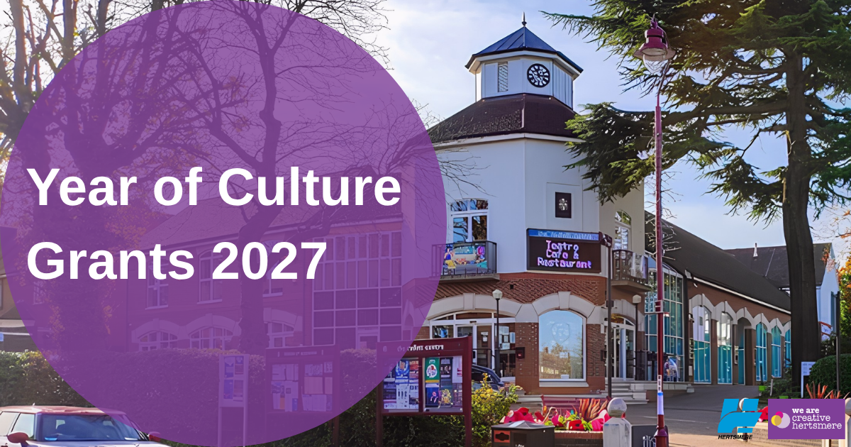

HERTSMERE BOROUGH COUNCIL
YEAR OF CULTURE CELEBRATION GRANTS – 2027

GUIDANCE NOTES

These notes will help you fill in your application form so please read them carefully. Applications may not be considered if incorrect or incomplete information is supplied. If you have any queries, please email grantapplications@hertsmere.gov.uk

The timetable for applications is as follows:
Round 1: January to March 2027
Applications open Monday 19th October 2026
Applications close Sunday 22nd November 2026

Round 2: April to June 2027
Applications open Monday 4th January 2027
Applications close Sunday 7th February 2027

Round 3: July to September 2027
Applications open Monday 29th March 2027
Applications close Sunday 2nd May 2027

Round 4: October to December 2027
Applications open Monday 5th July 2027
Applications close Sunday 8th August 2027

Please see below the theme for each month and ensure you submit your application within the correct round of applications.

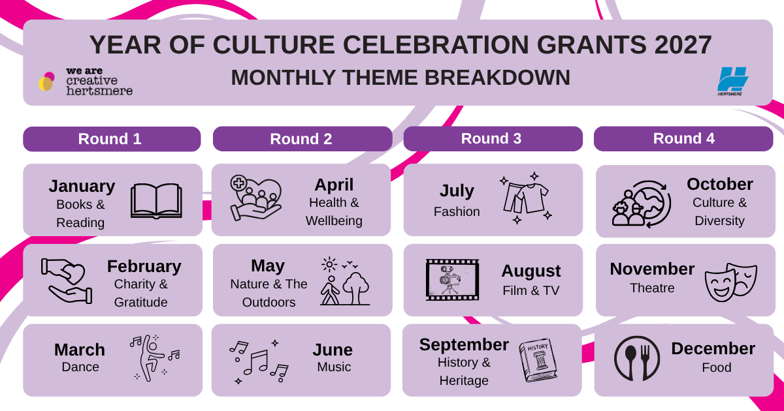
What can we apply for?

Applicants will be required to demonstrate that:
- The event is being delivered specifically as part of, or in celebration of, the Year of Culture 2027.
- Their event aligns with one of the Year of Culture monthly themes.
- The event takes place during the Year of Culture period (January to December 2027) and is held within the borough.
- The event is scheduled within, or as close as possible to, the relevant themed month.

This is not an exhaustive list, and we will consider all applications that fit the theme of the grant guidelines and benefit the residents of Hertsmere.

To ensure we have events throughout the year to celebrate the Year of Culture we ask that you choose a month that is relevant to you and your organisation. Please ensure you apply within the correct round of funding. Please see above the breakdown of monthly themes and their corresponding application periods in the box on page 1 of this document.

Who can apply?
- Applications will be accepted from organisations that are volunteer led or operated on a not-for-profit basis, such as, but not limited to:
  - registered charities (that have a charity number)
  - un-registered charities (with income under £5,000), constituted groups or clubs (e.g. including children, youth and the elderly, etc.)
  - Community Interest Companies (CIC) or Community Interest Organisations (CIO)
  - social enterprises
  - sports clubs
  - resident groups and clubs
  - schools and academies (providing the activity is beyond their statutory responsibilities)
  - faith based organisations (where they are including the wider community)
  - parish, town and community councils (on condition that the funding is for something that provides additionally)
- Organisations should have an open-door membership policy and provide services that are accessible to all. This does not preclude single focus organisations from applying as long as they can demonstrate that they comply with the Equality Act 2010. Organisations must supply a copy of their Equalities Policy.
- Organisations must benefit the residents of Hertsmere. Applications from countywide, regional or national organisations will be considered where the service/project delivered will specifically benefit the people of Hertsmere.
- In the case of projects that involve working with children, young people or vulnerable adults, the group or organisation must:
      - Have a safeguarding policy.
      - Have completed DBS checks as appropriate.

Completing the application form
- Please complete ALL sections of the form - leave no sections blank.
- Please also include a completed BACS form alongside your application This will ensure a quicker turn-around if your application has been approved.

Supplementary information required with your application:

Receiving your funding:
If you are successful, your funds will be paid electronically by BACS. In order to register on the Council’s financial system, you will need to provide ONE of the following pieces of information about your organisation:
- Copy of bank statement (less than 3 months old), transactions to be redacted
- Copy of blank cheque (crossed through)
- Paying-in slip
You will receive further information about these requirements if your application is successful.

Evaluation
- You will be asked to complete a short evaluation and share pictures of your event with us afterwards. You will receive more information about this if you are successful.
- You will be asked to forward to us any publicity and photographic evidence upon completion of the project/purchase via email to grantapplications@hertsmere.gov.uk. Please note that it is your responsibility to obtain the relevant consents to use photographs.

Remember to…
- Complete the application fully, leaving no parts blank.
- Provide a copy of your constitution.
- Provide a copy of your Equalities Policy.
- Provide a copy of your Safeguarding policy and be able to provide copies of current DBS checks when asked.

If you have any questions regarding the application process, please contact grantapplications@hertsmere.gov.uk and a member of the team will get in touch as soon as possible.

RETURN YOUR COMPLETED APPLICATIONS TO grantapplications@hertsmere.gov.uk

