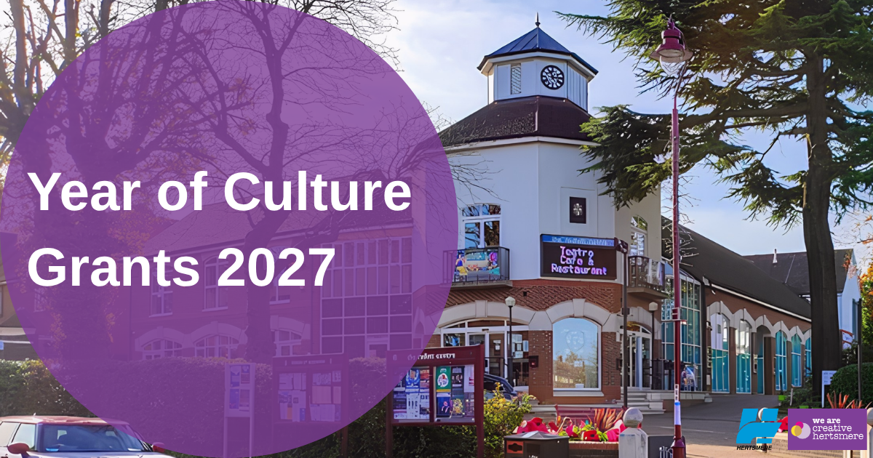

HERTSMERE BOROUGH COUNCIL

YEAR OF CULTURE CELEBRATION GRANTS – 2027

APPLICATION FORM

Hertsmere Borough Council is honoured to celebrate our rich heritage, diverse communities and talented local creatives, by making some funds available to local organisations.
A maximum of £500 can be applied for by organisations to showcase the people, places, stories and creativity that make our area unique.

PLEASE ENSURE YOU HAVE READ THE ASSOCIATED GUIDANCE NOTES AND REFERRED TO THE APPLICATION CHECKLIST AT THE END OF THIS FORM BEFORE COMPLETING AND SUBMITTING YOUR APPLICATION.

Please submit your completed application, a completed BACS form and any supporting documents needed to grantapplications@hertsmere.gov.uk

The timetable for applications is as follows:
Round 1: January to March 2027
Applications open Monday 19th October 2026
Applications close Sunday 22nd November 2026
Round 2: April to June 2027
Applications open Monday 4th January 2027
Applications close Sunday 7th February 2027
Round 3: July to September 2027
Applications open Monday 29th March 2027
Applications close Sunday 2nd May 2027
Round 4: October to December 2027
Applications open Monday 5th July 2027
Applications close Sunday 8th August 2027

Please see below the theme for each month and ensure you submit your application within the correct round of applications.
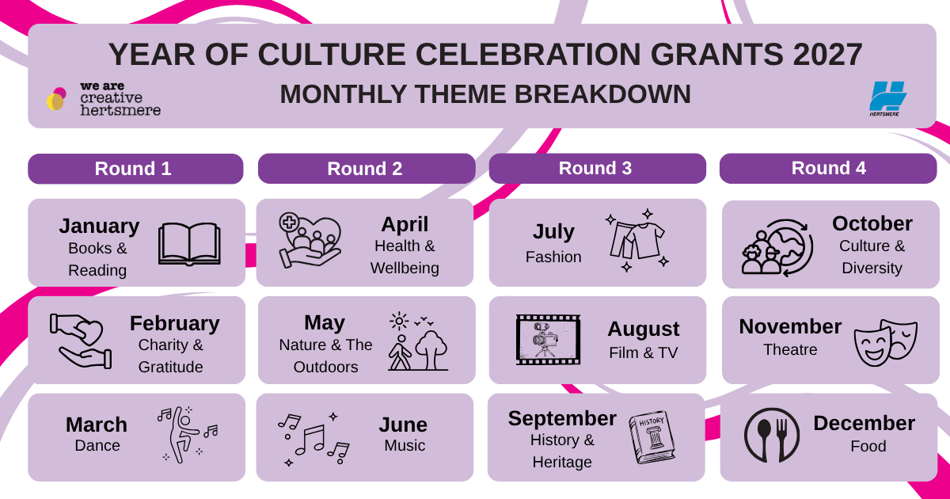

- Applicant Details
Name or organisation or group:

Contact:

Address:

Telephone number:

Email:

Tell us about your organisation - What you do, where do you meet, who are your clients/members: (maximum words: 250)

- Event/Project Details
Which month and theme are you applying for? (please see page 2)

Tell us about the event/project you are planning. Give a brief summary: (maximum words: 750)

Where and when will the event take place? (if applicable)  Date:  Time: | Location (please tick all that apply)
  Borehamwood
  Bushey
  Potters Bar
  Radlett
  Hertsmere wide
  Other (please specify)
How many Hertsmere residents will benefit?
Hertsmere Residents:
Children 0-14
Young People 15-24
Adults 25-59
Adults over 60
Total:

Would you be interested in a Mayoral visit? If yes, please complete the mayoral engagement form and return it.  The form can be found on the Hertsmere website here: Mayor of Hertsmere - Hertsmere Borough Council |  | Yes/No

- Financial Details
Amount Requested from Hertsmere Borough Council | £
Amount found from other sources | £
Total Cost of project/event | £
How will you spend any money you are awarded? (estimated amounts are fine)
Item | £
Authorisation
I hereby confirm that as far as I know, the information in this application is true and correct. I can confirm that my organisation has a constitution and has a bank account in its name with at least 2 signatories.
Signed: ………………………………………………………..
Position in organisation: …………………………………………
Date: ………………………………………………..

Please tick the box if you would be happy to receive other relevant information which we feel would be useful to you as an organisation or your beneficiaries.

- Data Protection
The information you have provided is needed for the administration of this service only. The information you provide will be held in confidence and stored securely.
Your information will not be used for any other purpose than described and will be securely destroyed upon completion in line with legislative requirements.

Application Checklist
- Completed application form
- Completed BACS form
- Any supporting documents required (please see below)
- A completed Mayoral engagement form if applicable

If you have NOT applied to the Borough Council for funding in the last 12 months, please provide:
  - A copy of your constitution.
  - A copy of your safeguarding policy (if appropriate)
  - A copy of your equality and diversity policy

Please submit your completed application, and any supporting documents needed to grantapplications@hertsmere.gov.uk

